**Plots Thoughts and information for final paper**

1. Very nice example which demonstrate both of my assumptions:
   1. Same devices should have the same normal behavior
   2. IoT devices should present seasonality in their behavior

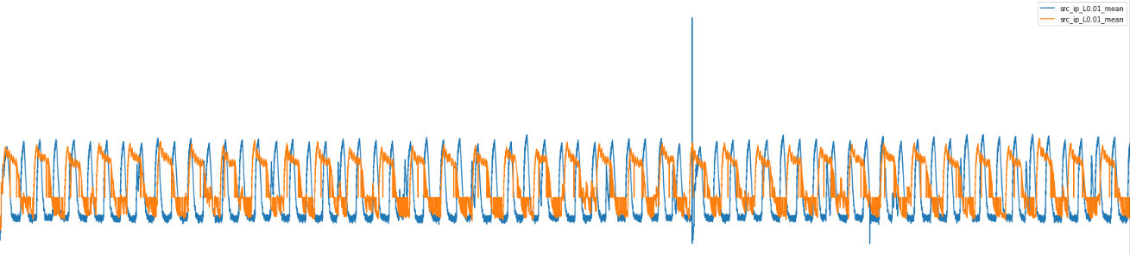In this plot we see the packets mean in 1min window for 2 Provision Security Cameras